The School District City of Erie, PA

February 2025

Bidder Must Deposit With

Bid – **CERTIFIED CHECK** Or

BID BOND 5% of Total Bid

**BID ON –** Power Wave 300C Advanced Process Welder and Associated Training

## The Board of Directors

of the School District

of the City of Erie, PA

Gentlemen:

We, the undersigned, propose to furnish and install the following **BID on Power Wave 300C Advanced Process Welder and Associated Training:**

DOLLARS ($_____________)

Bids shall be sealed and endorsed on the envelope, or on the subject line on electronic submissions, **“Power Wave 300C Advanced Process Welder and Associated Training”** and delivered to School District of the City of Erie, Administration Building,1910 Sassafras Street, Erie, PA 16502, Board Secretary Office, ATTN: BIDS, by February 25th by 11:00 am. Bids shall be delivered either in person, via USPS, a contract carrier such as UPS, FedEx, etc., or via electronic submission to bids@eriesd.org.  Late bids will be rejected.  Bids will be opened utilizing an online format on February 25th at 11:15 am. Award of bid may be made at the regular meeting of the Board onMarch 12th, 2025 at 6:00 pm.

The School District will conduct the bid opening utilizing an online format at the date and time identified above. The School District will provide interested proposers with a link to participate in the bid opening. If an interested proposer requires reasonable accommodations to participate in an online format bid opening due to a disability, if the interested proposer wishes to participate in the meeting but does not have internet access, or if a member of the public wishes to view the opening electronically, contact Neal Brokman, Assistant Superintendent, at [nbrokman@eriesd.org](mailto:nbrokman@eriesd.org).

The Board of School Directors will consider accepting the bid of the lowest responsible bidder meeting specifications, kind, quality and material being equal, but shall have the right to reject any and all bids and to waive defects in form. The Board is not obligated to accept the lowest or any other bid.

Respectfully submitted:

The School District City of Erie, PA

***Brian J. Polito, CPA District Administration Building***

***Superintendent of Schools 1910 Sassafras Street Erie PA 16502***

# GENERAL CONDITIONS

Bids shall be submitted on the Bidding Blank attached hereto, and should be submitted through the means identified on the Bidding Blank.

No bids will be entertained unless accompanied by a deposit, as a **CERTIFIED CHECK or BID BOND** in the amount of five per cent (5%) of the total bid, made payable to The School District City of Erie and enclosed in the envelope containing the bid.

No bid received can be withdrawn prior to the close of the regular meeting of the Board of School Directors next succeeding the opening of the bids. Bidder agrees that the School District of the City of Erie shall have up to sixty (60) days to accept or reject the bid and bidder agrees that the bid quote shall remain open for that period. The Board of School Directors may reject any bid, or portion of any bid, for any reason or no reason.

The special attention of the bidders is directed to the fact that no claims for relief on account of mistakes or omissions in the bidding will be considered and the contractors will be held strictly to their bids, or, alternatively, and at the sole discretion of the Board of School Directors, their deposit may be forfeited. In addition to other remedies available to the School District, the deposit shall be forfeited if the successful bidder fails to execute an agreement or perform as required.

**Standard of Quality**: The specific mention of a manufacturer’s name shall be understood to indicate a standard of quality or design, and not as limiting competition thereon or excluding other goods equal in every respect to the materials or goods specified in the opinion of the Controller or his designee. If you do not bid on our specifications as listed, please fill in manufacturer’s name and model number of items you intend to furnish as an equal alternate. The Career and Technical Educational Director, or his designee, shall determine, in his sole discretion, whether the alternate item is an approved equal.

Bidders are to submit prices on both the rate and the total. Bidders please indicate length of time prices will remain firm. If a “Rate” is given on an item, a “Total” must be given on the item. Awards may be made item by item and bidders hereby agree to furnish the items awarded to them. All supplies furnished upon the contract not up to specifications will be rejected.

All charges for transportation, freight, express and parcel post are to be paid by the successful bidder. It is understood that the bidder agrees to deliver any items on which bids are accepted.

Completion of contract shall not exceed sixty days after award is made. The successful bidder will be required to execute a contract with the School District if identified as the apparent low bidder. A fully executed contract must be received by the School District prior to final award by the Board of School Directors. The form of the contract is enclosed with this bid packet.

All items to be delivered to the Erie High School. If you have any questions, please contact Jason Burgert, Career and Technical Education Director at 814-874-6225 or [jburgert@eriesd.org](mailto:jburgert@eriesd.org).

**SPECIFICATIONS**

The following specifications are approved by the Board of Directors for purchase or approved equal as approved by the Career and Technical Education Director.

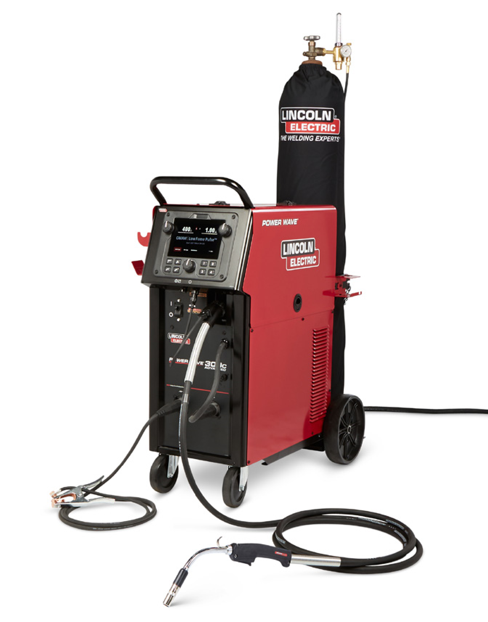

**Processes »**

SMAW, GTAW, GMAW, GMAW-P, FCAW

SMAW-AC*, GTAW-AC*, GTAW-HF*,STT MIG*

**Applications »**

General Fabrication, Education

**Output »**

**Input »**

**Product Numbers »**

POWER WAVE 300C STANDARD

**K4487-1**

POWER WAVE 300C ADVANCED

**K4488-1**

POWER WAVE 300C ADVANCED EDUCATIONAL ONE-PAK®

**K4934-1**

*Available on Power Wave 300C Advanced Model

For full waveform list please visit

www.PowerWaveSoftware.com

**ADVANCED PROCESS WELDER**

**POWER WAVE**

**®**

**300C**

From technical training to industrial fabrication, the Power Wave 300C

delivers the ultimate 300 amp- “Do-Everything” welder. Packed with all the

arc performance and technology you expect from a Power Wave system,

this compact machine takes the industrial “all-in-one” class of welders to

the next level.

**Publication E5.102**

| Issue Date 09/21

© Lincoln Global Inc. All Rights Reserved All trademarks and registered trademarks are the property of their respective owners.

www.lincolnelectric.com

**THE ULTIMATE ALL-IN-ONE MACHINE**

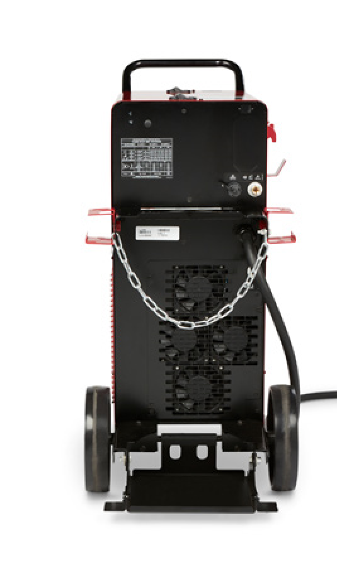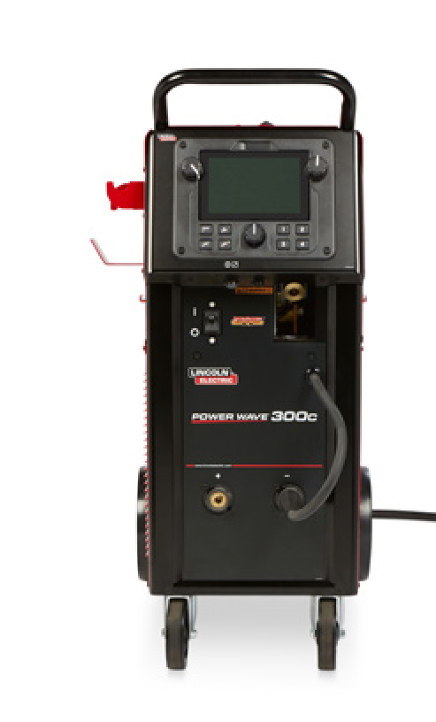

**KEY FEATURES**

**•**

**Best-in-Class Performance**

Industry’s

only true 300Amp, 100% Duty Cycle,

All-Process Machine.

**•**

**All-Process Versatility**

Stick, TIG, MIG,

Flux-Cored, Arc Gouging processes, with

advanced weld modes and integrated

High Frequency and AC/DC capabilities*.

**•**

**Intelligent Connectivity**

Intelligent,

operator-focused interface and powerful

Industry 4.0 capabilities including

CheckPoint® Production Monitoring.

**•**

**Flexible Input Power**

PowerConnect®

Technology allows for 200V-600V input

power while maintaining consistent and

reliable arc performance.

**•**

**Ready-to-Run™ Design**

Standard features

for simple and straightforward operation,

including cable management hooks,

integrated cart with tilting bottle rack,

and TIG solenoid.

**KEY CONTROLS - POWER SOURCE**

**KEY CONTROLS - USER INTERFACE**

.

1

User Interface / Controls w/USB Port

2

.

Cable / Torch Hanger

3

.

Remote Connection, 12 pin

.

4

Gun Trigger Connection, 4 pin

5

.

Power Source ON/OFF

6

.

MIG/FCAW Gun Connection

7

.

Sense Lead Connection (if required)

.

8

Twist Mate™ Connections w/ integrated

TIG gas solenoid

.

1

Auxiliary 115V Outlet (optional K2829-1)

.

2

Ethernet Connection

.

3

MIG/FCAW Shielding Gas Input

4

.

Tool Holder

5

.

Power Cable Input

6

.

TIG Shielding Gas Input

.

7

Tilting Bottle Rack

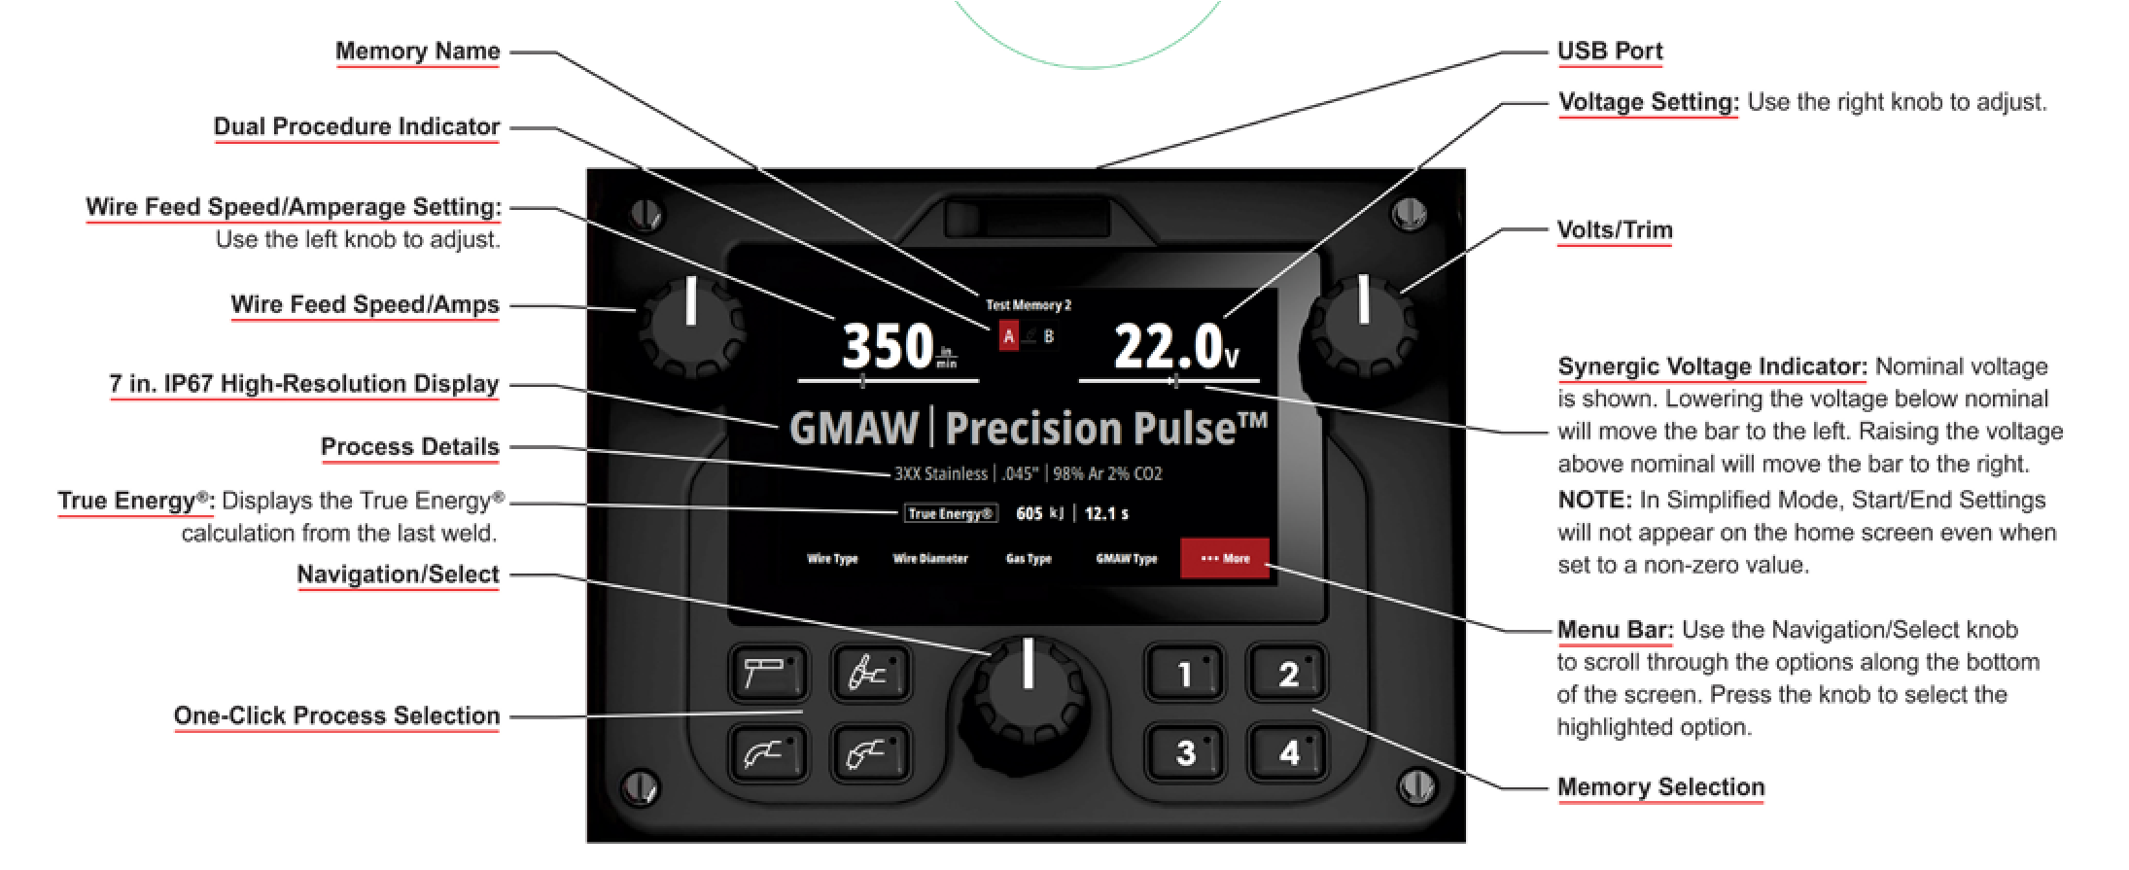

*Available on Power Wave 300C Advanced Model

1

1

2

3

6

5

4

7

2

3

4

5

8

6

7

# NEXT GENERATION OF SIMPLICITY & CONTROL

The Power Wave 300c user interface helps maximize arc time and allow operators of all skill levels to focus more on making great welds.

* One-button process changes
* Straightforward, easy-to-understand navigation
* Memory buttons for preferred settings
* ArcFX® Technology for visual arc settings feedback
* Single point of use – all controls in one location on the feeder
* Multilingual options for true global compatibility

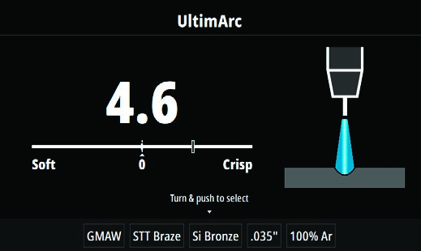

Power Wave 300C - process confi guration screen with ArcFX® Technology

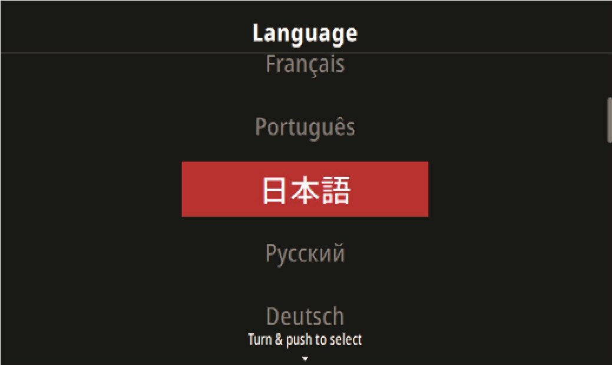Power Wave 300C - Home Screen

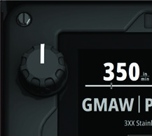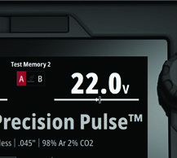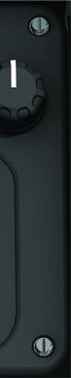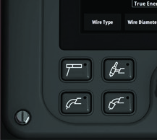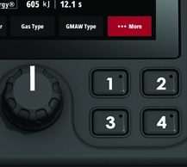

Power Wave 300C - language option screen

**FINE-TUNED ARC PERFORMANCE**

The Power Wave 300C comes loaded with an exapansive list of weld modes optimized for maximum performance with the industry’s most common fi ller metals, wire diameters, and gas mixtures off ered by Lincoln’s Waveform Control Technology®.

* Stick modes optimized for cellulosic and low hydrogen electrodes
* MIG modes optimized for 0.035-0.052 in. for steel, 0.035-0.045 in. for stainless, 0.045-0.052 in. for metal cored, and 0.035, 3/64, and 1/16 in. for aluminum
* MIG modes optimized for simplicity (Smart Pulse™) and fume management (Low Fume Pulse™)*
* Flux-cored modes optimized for 0.045 in., 0.052 in., 1/16 in
* High-Frequency and AC/DC TIG Modes*

* Available on the Power Wave 300C Advanced Model

## K4866-1 Power Wave 300C Dual Gas Bottle Upgrade Kit

**MODELS & PACKAGES AVAILABLE**

**K4487-1 Power Wave 300C Standard**

•

DC Output

•

Multi-Process Capabilities

**What’s Included**

•

Magnum® PRO Curve™ 300 Gun Ready-Pak (K2951-2-6-45)

•

Harris Flowmeter/Regulator and Hose Kit (3100211)

•

10

ft. (3 m) Work Lead

•

0.035/0.045

in. (0.9/1.2 mm) Combination V-Groove Drive Rolls (Included in Wire Drive Assembly)

(KP1696-1)

**K4488-1 Power Wave 300C Advanced**

•

AC/DC Output

•

Multi-Process Capabilities, with Advanced Waveforms:

-

Smart Pulse™, Low Fume Pulse™, and STT®

-

HF TIG including AC Aluminum Modes

**What’s Included**

•

Magnum PRO Curve 300 Gun Ready-Pak (K2951-2-6-45)

•

Harris Flowmeter/Regulator and Hose Kit (3100211)

•

10

ft. (3 m) Work Lead

•

0.035/0.045

in. (0.9/1.2 mm) Combination V-Groove Drive Rolls (Included in Wire Drive Assembly)

(KP1696-1)

**K4934-1 Power Wave 300C Advanced Educational One-Pak**

**What’s Included**

•

Power Wave 300C Advanced (K4488-1)

•

Magnum PRO Curve 300 Gun Ready-Pak (K2951-2-6-45)

•

Harris Flowmeter/Regulator and Hose Kit (3100211)

•

10

ft. (3 m) Work Lead

•

PTA-17F TIG Torch Ready-Pak (12.5 ft, 1 pc.) (K1782-14)

•

Foot Amptrol™ - 25 ft (7.6 m), 12-pin (K870-2)

•

Stick Electrode Holder, Cable (w/ Twist Mate) (K2374-1)

•

0.035/0.045

in. (0.9/1.2 mm) Combination V-Groove Drive Rolls (Included in Wire Drive Assembly)

(KP1696-1)

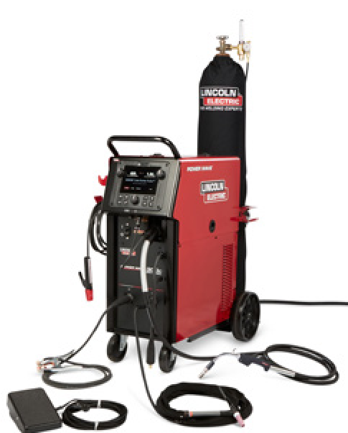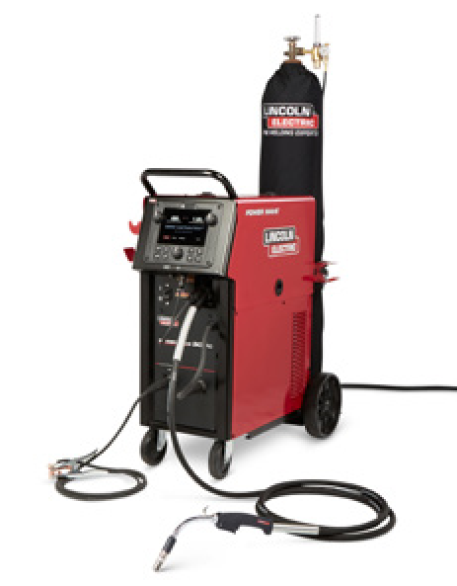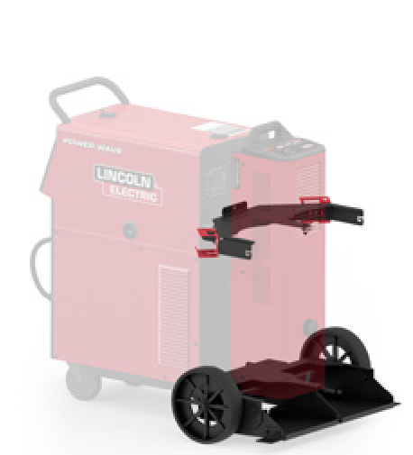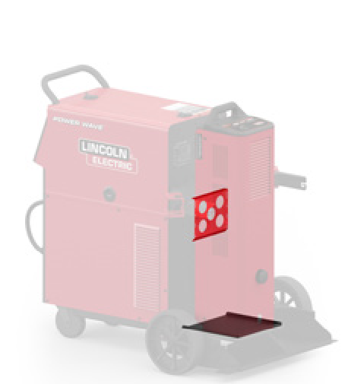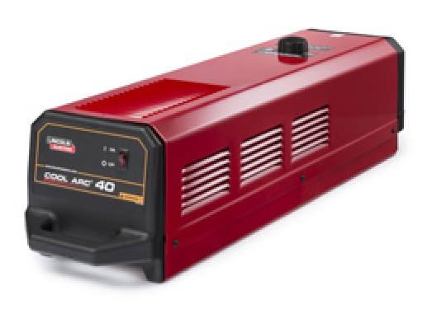

**ADDITIONAL POWER WAVE 300C ACCESSORIES**

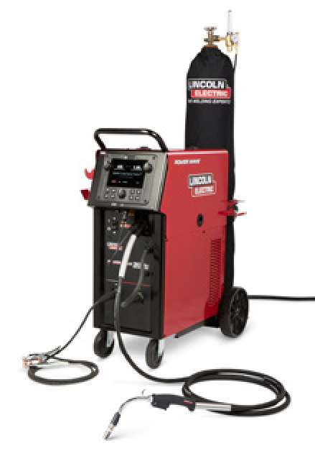

Allows for the use of multiple gas bottles or a combination of a gas bottle

and water cooler on the rear of a Power

Wave 300C

## K4898-1 Power Wave 300C Water Cooler Adapter Kit

Allows Cool Arc® 40 Water Cooler to be installed in place of a gas bottle on the 300C single or dual bottle rack. Kit Includes: (1) 300C Cool Arc 40 Mounting Assembly and Hardware Kit, (1) Cool Arc 40 CGA to QD Water Hose Extension Kit, and (2) Quick Disconnect Adapters (KP4642-1).

## K1813-1 Cool Arc 40 Water Cooler

Industrial water cooler that can function in both horizontal and vertical orientation for minimized footprint

* For use of Lincoln Electric Magnum PRO semi-automatic water cooled guns, order K466-6 connector kit.

# CONSUMABLES

## CONTACT TIPS AND LINERS

|  |  |  |
| --- | --- | --- |
| Wire Diameter - in. (mm) | Description | Order No. |

|  |  |  |
| --- | --- | --- |
| 0.045 (1.2) | 350A Contact Tips (10) | KP2744-045 |
| 0.035 (0.9) | 350A Contact Tips (10) | KP2744-035 |
| 0.030 (0.8) | 350A Contact Tips (10) | KP2744-030 |
| 0.025 (0.6) | 350A Contact Tips (10) | KP2744-025 |
| 0.035 -0.045 (0.9 - 1.2) | Magnum PRO Curve 15 ft (4.5 m) Liner Solid Wire (1) | KP44-3545-15 |

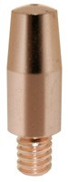**FOR STEEL / STAINLESS STEEL / SILICON BRONZE**

Shown:

KP2744-045, Contact Tip

|  |  |  |
| --- | --- | --- |
| Nozzle Diameter - in. (mm) | Description | Order No. |
| **350A** |  |  |
| 0.375 (9.5) | Thread-on Flush Nozzle | KP2742-1-38F |
| 0.5 (12.7) | Thread-on Flush Nozzle | KP2742-1-50F |
| 0.375 (9.5) | Thread-on Recessed Nozzle | KP2742-1-38R |
| 0.5 (12.7) | Thread-on Recessed Nozzle | KP2742-1-50R |
| – | Steel Thread-on Nozzle | KP2746-1 |
| **550A** |  |  |
| 0.625 (15.9) | Thread-on Flush Nozzle | KP2743-1-62F |
| 0.75 (19.0) | Thread-on Flush Nozzle | KP2743-1-75F |
| 0.625 (15.9) | AL Thread-on Recessed Nozzle | KP2743-1-62RA |
| 0.75 (19.0) | Thread-on Recessed Nozzle | KP2743-1-75R |
| – | Steel Thread-on Diffuser | KP2747-1 |

## NOZZLES AND DIFFUSERS

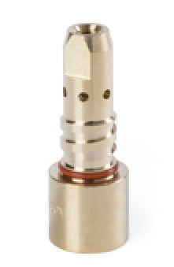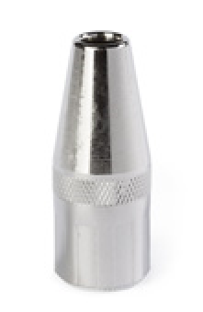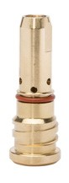

Shown:

KP2742-1-38F, Thread-on Nozzel

Shown:

KP2746-1, Steel Thread-on Diffuser

Shown:

*For more options, please refer to the Magnum PRO Instruction Manual.*KP2747-1, Steel Thread-on Diffuser

## DRIVE ROLL KITS

|  |  |  |
| --- | --- | --- |
| Wire Type | Wire Diameter - in. (mm) | Order No. |
| Solid | 0.023-0.030 (0.6-0.8)  0.035 (0.9)  0.035/0.045 Combination  0.040 (1.0)  0.045 (1.2) | KP1696-030S  KP1696-035S  KP1696-1  KP1696-2  KP1696-045S |
| Cored | 0.035 (0.9)  0.045 (1.2) | KP1697-035C KP1697-045C |
| Aluminum | 0.035 (0.9)  3/64 (1.2)  1/16 (1.6) | KP1695-035A  KP1695-3/64A  KP1695-1/16A |

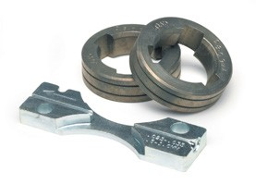Shown:

KP1697-035C, Cored Drive Roll Kit

# RECOMMENDED ACCESSORIES

## GENERAL OPTIONS

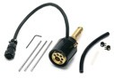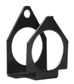

**Power Wave 300C 115V Auxiliary Kit** Adds a duplex 115v outlet to the rear of the machine. Includes harness and PC board.

**Order K2829-1**

**Screen Protector Order KP4735-1**

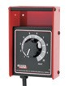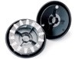**Remote Output Control with 12-pin Universal Connector**

Consists of a control box with choice of two cable lengths. Permits remote adjustment of output. **Order K857-2 (25 ft, 7.6 m)**

**Order K857-3 (100 ft, 30.5 m)**

## WIRE FEEDER OPTIONS

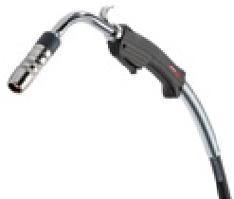**Magnum PRO Welding Guns**

**See publications E12.05 and E12.08.**

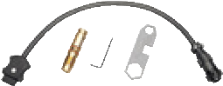**Gun Connector Kit**

**Power Wave 300C / POWER MIG** Configures Lincoln Electric Magnum

PRO guns to connect to Power Wave 300C and POWER MIG® power sources. For use with KP42 & KP44

series liners

**Order K466-6**

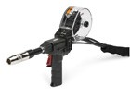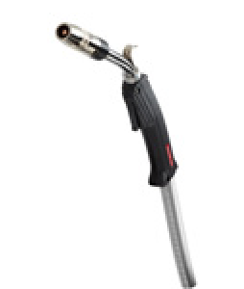**Magnum PRO Dual Procedure Adapter** Required to use Magnum PRO Dual Procedure or Dual Schedule guns with the Power Wave 300C **Order K3159-1**

**Magnum Curve 300 AL Push Gun**

10 ft. *The Magnum PRO AL Push Gun is a cost effective solution for welding 3/64-1/16 in. aluminum wire over distances up to 10 ft. This welding gun solution was designed with the soft wire in mind, and includes the proper expendables to ensure premium performance for the recommended applications **Order K4700-1-6-116A**

**Fast-Mate™ Adapter**

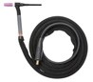Allows guns with a Fast-Mate™ style back end to connect into Power Wave 300C and POWER

MIG power sources **Order K489-8**

**Spindle Adapter for Small Spools** Permits 8 in. (200 mm) O.D. spools to be mounted on 2 in. (51 mm) O.D. spindles **Order K468**

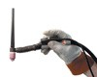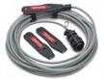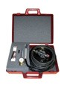**Spindle Adapter for 14lb Coils** Permits 14 lb. (6 kg) Innershield® coils to be mounted on 2 in (51mm) O.D. spindles **Order K435**

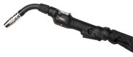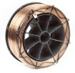

**Readi-Reel™ Adapter** Adapts 22-30 lb. (10-14 kg) Lincoln Readi-Reels® of electrode to 2 in (51mm) spindle **Order K363P**

**Magnum PRO Al Fixed Conduit**

**Push-Pull Guns** The new, improved Magnum

PRO AL Fixed Conduit Push-Pull Guns feature a new rigid liner which provides a smooth, premium aluminum welding solution. The enhanced feeding capabilities will reduce downtime and increase arc on time. **Order K4797-2 (Air Cooled) or**

**K4798-2 (Water Cooled) E12.14**

**Magnum Pro 250LX GT Spool Gun**

**With longer-lasting Magnum PRO Expendables and direct connect functionality**

The Magnum PRO 250LX

GT spool gun results in less downtime and hassle-free setup. *Will need Lincoln 7-pin to

12-pin Adapter (K2910-1)

**Order K3569-2 and K2910-1**

**E12.28**

**TIG OPTIONS**

**PTA-17 Air Cooled TIG**

**Ready-Pak®**

Flexible head and Ultra-Flex™ cables provide ultimate comfort and maneuverability. Preconfigured package with K1622-1 Twist-Mate™ adapter, cable cover. Includes: #7 nozzle, 1/16 in. (1.6 mm) and 3/32 in. (2.4 mm) collets ,collet bodies and E3® Tungsten

**Order: K1782-14** (12.5 ft 3.8 m)

**Order K1782-18** (25 ft, 7.6 m)

**Additional TIG torch options in E12.150**

**Arc Start Switch (00001862)** Attaches to TIG torch for convenient finger control. Comes equipped with 12-pin connector **Order K814-2**

**Hand Amptrol Rotary Track Style,**

**12-pin** Amphenol (25 ft) Remote current control for TIG welding **Order K963-4**

**Foot Amptrol (00002440)** Provides 25 ft. (7.6 m) of remote output control for TIG welding.

(12-pin plug connection). **Order K870-2**

**TIG-Mate 20 Water-Cooled TIG**

**Torch Starter Pack** Get everything you need for TIG welding in one complete easy to-order kit packaged in its own portable carrying case. Includes: PTW-20 torch, parts kit, Harris flowmeter/regulator, Twist-Mate adapter, 10 ft. (3.0 m) gas hose, water hose coupler and water hoses, work clamp and cable. **Order K2267-1**

## PRODUCT SPECIFICATIONS

|  |  |  |  |  |  |  |  |
| --- | --- | --- | --- | --- | --- | --- | --- |
| **Product Name** | **Product Number** | **Input Voltage / Phase / Hertz** | **Output Range** | **Rated Output / Voltage / Duty Cycle** | **Input Current @ Rated Output** | **Dimensions**  **H x W x D in (mm)** | **Net**  **Weight lb (kg)** |
| Power Wave 300C Standard | K4487-1 | 200-208/220-230/380415/460/575/1/3/50/60 | 5-350A | GMAW: 350A / 31.5 V/ 40%  GMAW: 300A / 29 V / 100%  SMAW: 325A / 33V / 40%  SMAW: 280A / 31.2V/100%  FCAW: 350A / 31.5 V/ 40%  FCAW: 300A / 29 V / 100%  GTAW: 325A / 23V / 40%  GTAW: 300A / 22V / 100% | 3ph /1ph / 40% Duty Cycle:  44/40/25/20/16.5  3ph /1ph/ 100% Duty Cycle:  35/32/19.5/16/14 | 39.67 x 20.65 x  39.60  (1007.6 x 524.5 x 1005.8) | 193  (87.5) |
| Power Wave 300C Advanced | K4488-1 | 226  (102.5) |
| Power Wave 300C Advanced Educational One-Pak | K4934-1 |

For best welding results with Lincoln Electric® equipment, always use Lincoln Electric consumables. Visit www.lincolnelectric.com for more details.

CUSTOMER ASSISTANCE POLICY

The business of Lincoln Electric is manufacturing and selling high quality welding equipment, automated welding systems, consumables, and cutting equipment. Our challenge is to meet the needs of our customers, who are experts in their fields, and to exceed their expectations. On occasion, purchasers may ask Lincoln Electric for information or technical information about their use of our products. Our employees respond to inquiries to the best of their ability based on information and specifications provided to them by the customers and the knowledge they may have concerning the application. Our employees, however, are not in a position to verify the information provided or to evaluate the engineering requirements for the particular weldment, or to provide engineering advice in relation to a specific situation. Accordingly, Lincoln Electric does not warrant or guarantee or assume any liability with respect to such information or communications. Moreover, the provision of such information or technical information does not create, expand, or alter any warranty on our products. Any express or implied warranty that might arise from the information or technical information, including any implied warranty of merchantability or any warranty of fitness for any customers’ particular purpose or any other equivalent or similar warranty is specifically disclaimed. Lincoln Electric is a responsive manufacturer, but the definition of specifications, and the selection and use of specific products sold by Lincoln Electric is solely within the control of, and remains the sole responsibility of the customer. Many variables beyond the control of Lincoln Electric affect the results obtained in applying these types of fabrication methods and service requirements.

Subject to Change – This information is accurate to the best of our knowledge at the time of printing. Please refer to www.lincolnelectric.com for any updated information.

**The Lincoln Electric Company** 22801 St. Clair Avenue • Cleveland, OH • 44117-1199 • U.S.A. www.lincolnelectric.com

NAME OF VENDOR

ADDRESS

CONTACT PERSON

TELEPHONE NUMBER

First, the undersigned having carefully examined the **Bid for Power Wave 300C Advanced Process Welder and Associated Training** in accordance with the specifications of the proposal, submits this proposal and agrees to furnish and perform the specified **Power Wave 300C Advanced Process Welder and Associated Training** for the School District of the City of Erie for the amounts indicated on page 1 of the Bid.

Second, the undersigned agrees to enter into a written contract to furnish such materials and services as required in the proposal specifications.

Third, the following quotation prices are listed as firm for a period of __________ after the due date of this request for bid.

**NOTE: The School District of the City of Erie will not be liable and will not pay for any applicable costs not included and detailed in the Bid.**

Signature

Date

Title or Office

**INSTRUCTIONS FOR NON-COLLUSION AFFIDAVIT**

1. This Non-Collusion Affidavit is material to any contract awarded pursuant to this RFP. According to the Pennsylvania Antibid-Rigging Act. 73 P.S. 1611 et seq. governmental agencies may require Non-Collusion Affidavits to be submitted together with bids or RFP’s.
2. This Non-Collusion Affidavit must be executed by the member, officer or employee of the Vendor who makes the final decision on prices and amounts quoted in the RFP.
3. Bid/RFP rigging and other efforts to restrain competition, and the making of false sworn statements in connection with the submission of bids or RFP’s are unlawful and may be subject to criminal prosecution. The person who signs the affidavit should examine it carefully before signing and assure himself/herself that each statement is true and accurate, making diligent inquiry, as necessary, of all other persons employed by or associated with the Vendor with responsibilities for the preparation, approval, or submissions of the RFP.
4. In case of a RFP submitted by a joint venture, each party to the venture must be identified in the RFP/Bid documents, and an affidavit must be submitted separately on behalf of each party.
5. The term “complementary RFP” as used in the Affidavit has the meaning commonly associated with that term in the bidding/RFP process, and includes the knowing submission of RFP’s higher than the RFP of another Vendor, any intentionally high or noncompetitive RFP, and any other form of RFP submitted for the purpose of giving a false appearance of competition.
6. Failure to file an Affidavit in compliance with these instructions will result in disqualification of the RFP.

**NON-COLLUSION AFFIDAVIT**

**BID ON – Power Wave 300C Advanced Process Welder and Associated Training**

State of

County of

I state that I am of

(Title) (Name of Vendor)

and that I am authorized to make this affidavit on behalf of my company, and its owners, directors, and officers, I am the person responsible in my company for the price(s) and the amount of this Request for Proposal (RFP).

I state that:

1. The price(s) and amount of this RFP have been arrived at independently and without consultation, communication, or agreement with any other Vendor.
2. Neither the price(s) nor the amount of this RFP, and neither the approximate price(s) nor the approximate amount of this RFP, have been disclosed to any other Vendor, and they will not be disclosed before the RFP submission to The School District of the City of Erie.
3. No attempt has been made or will be made to induce any Vendor or person to refrain from submitting an RFP to The School District of the City of Erie, or to submit an RFP higher than this RFP, or to submit any intentionally high or noncompetitive RFP or other form of complementary RFP.
4. The RFP of my company is made in good faith and not pursuant to any agreement or discussion with or inducement from, any Vendor or person to submit a complementary or other noncompetitive RFP.
5. , its affiliates, subsidiaries, officers, directors and employees

(Name of my Company)

are not currently under investigation by any governmental agency and have not in the last four years been convicted or found liable for any act prohibited by State or Federal law in any jurisdiction, involving conspiracy or collusion with respect to submitting an RFP to any public entity, except as follows:

I state that understand and acknowledges that the above

(Name of my Company)

representations are material and important, and will be relied on by The School District of the City of Erie when recommending for award the agreement for which this RFP is submitted, I understand and my company understands that any misstatement in this affidavit is and shall be treated as fraudulent concealment from the School District of the City of Erie of the true facts relating to the submission of RFP’s for this agreement.

Signature of Authorized Person

(Print Name of Authorized Person and Company Position)

Sworn to and subscribed before

Me this day of

, 20

(Notary Public) (My Commission Expires)